**DAILY ONLINE ACTIVITIES SUMMARY**

|  |  |  |  |  |  |  |  |  |
| --- | --- | --- | --- | --- | --- | --- | --- | --- |
| **Date:** | **15/06/2020** | | | | | **Name:** | **Shwetha** | |
| **Sem & Sec** | **8th B** | | | | | **USN:** | **4AL16CS101** | |
| **Online Test Summary** | | | | | | | | |
| **Subject** | | **SMS** | | | | | | |
| **Max. Marks** | | **60** | | **Score** | | | **No mail received** | |
| **Certification Course Summary** | | | | | | | | |
| **Course** | **Artificial intelligence in python** | | | | | | | |
| **Certificate Provider** | | | **Great learning** | | **Duration** | | | **7hr** |
| **Coding Challenges** | | | | | | | | |
| **Problem Statement:**  **Python implementation to reverse bits v of number.** | | | | | | | | |
| **Status: Solved**  **Solution link: https://github.com/alvas-education-foundation/Shwetha-** | | | | | | | | |
| **Uploaded the report in Github** | | | | | **Yes** | | | |
| **If yes Repository name** | | | | | **Shwetha-** | | | |
| **Uploaded the report in slack** | | | | | **Yes** | | | |

Certification Course Details:

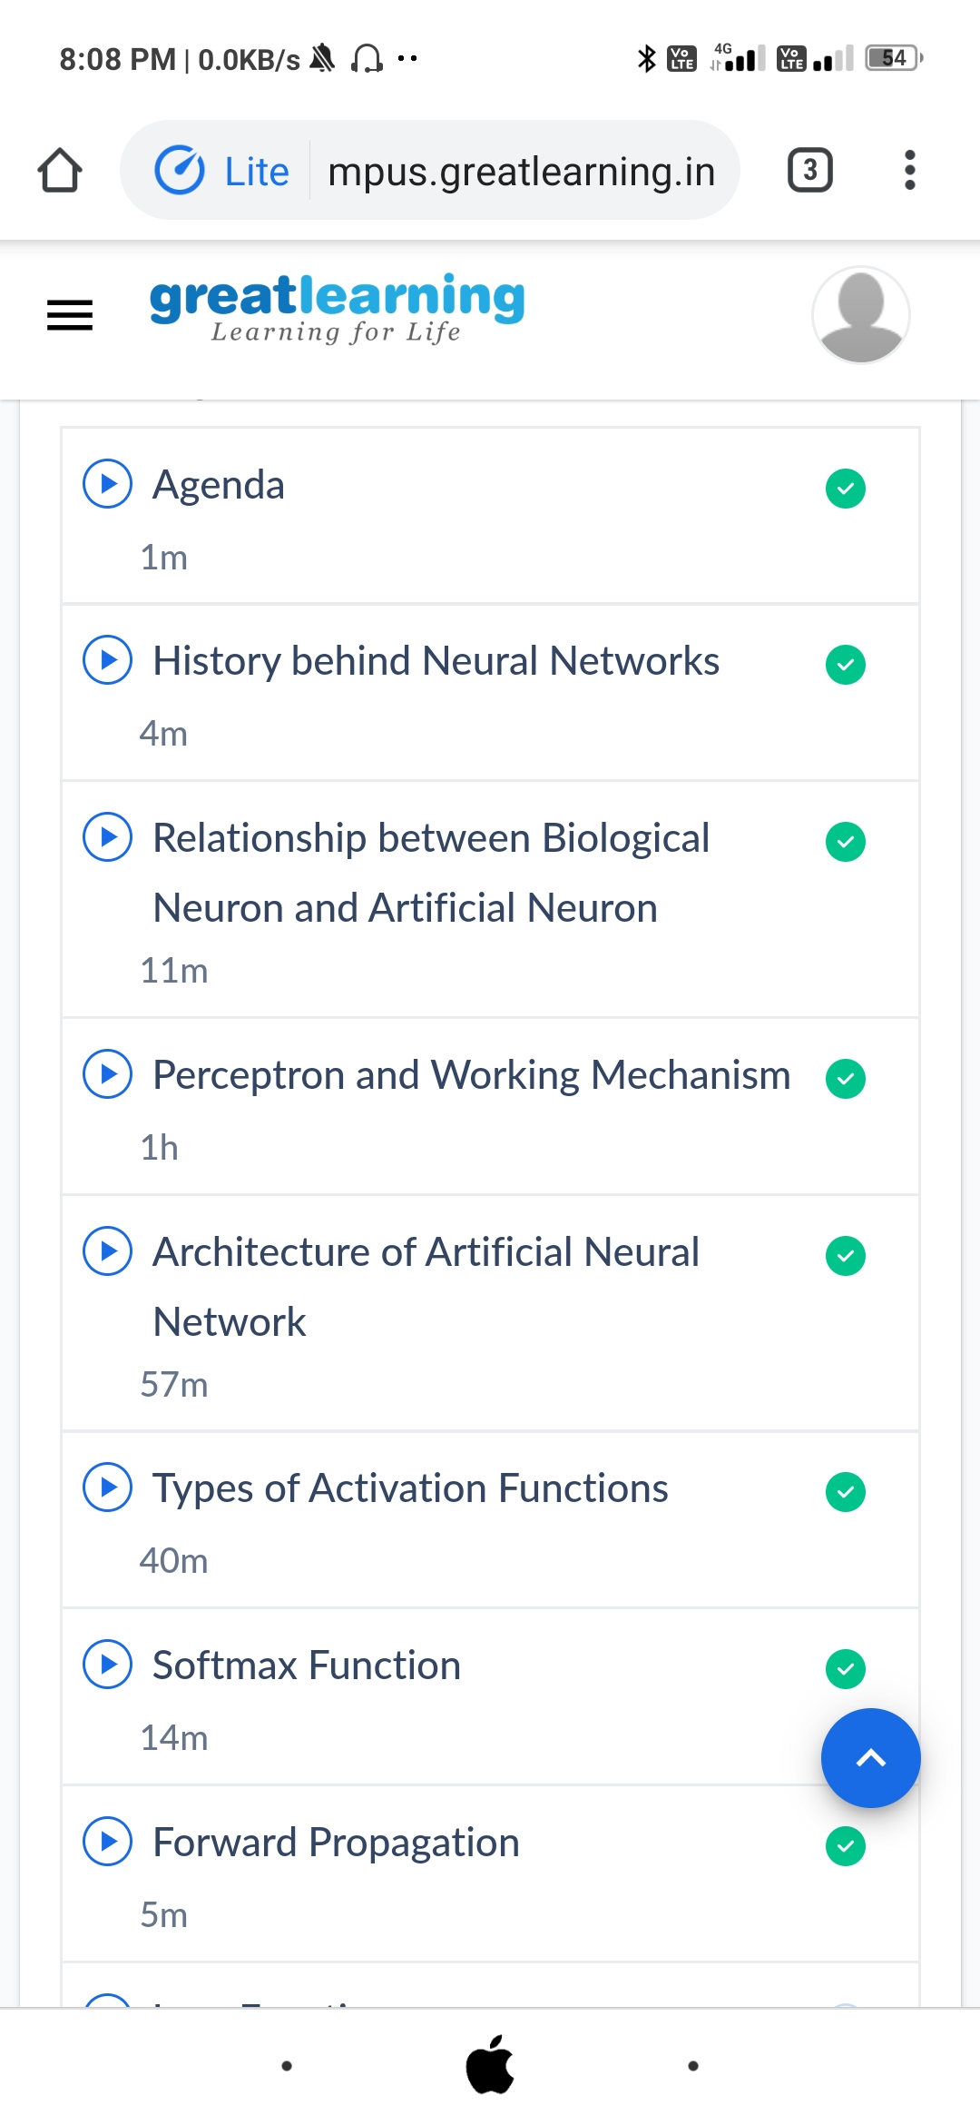

*Coding Challenges Details:*

defreverseBits(n):

rev=0

#traversingbitsof'n'fromtheright

while(n>0):

#bitwiseleftshift'rev'by1

rev=rev<<1

#ifcurrentbitis'1'

if(n&1==1):

rev=rev^1

#bitwiserightshift'n'by1

n=n>>1

returnrev

n=11

print(reverseBits(n))